Execrcise programs

**Calculate basic statistics (total, max, min) using for loop and if else condition logics**

* Create an array called expenses that contains at least 5 different expense amounts.
* Calculate the total expenses by summing all the elements of the array.
* Find the highest and lowest individual expenses within the array.

Solution is

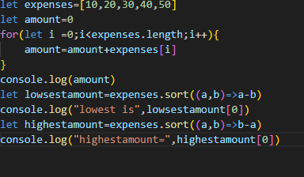

Exercise 2

**Manipulate an array of strings (add, remove, sort)**

* Create an array named studentNames with the names of your students.
* Add a new student name to the beginning of the array.
* Remove the last student name from the array.
* Alphabetize the student names within the array.

Learning objective

Solution

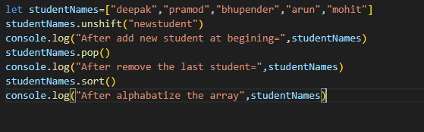

o/p

**Apply transformations and calculations to array elements, and filter elements based on a condition**

* You have an array called productPrices with various product prices.
* Apply a 10% discount to all prices using the map method and store the results in a new array called discountedPrices.
* Use the filter method to create a new array called affordableProducts containing only products priced below $50
* Calculate the total cost of all items in the affordableProducts array using the reduce method.

Learning objective

o/p

